CLA Transfer support system

April 23, 2018, Version 1.3

Sean Leckie

Kevin Cochran

Alex Jones

Jeffrey Ladd

Christopher Plaisime

Table of Contents

1 - Introduction 3

1.1 – Overview 3

2 – Administrator 4

2.1 – Login 4

2.2 – Advisor Dashboard 5

2.3 – Add Student Profile 6

2.4 – Student Profile 6

2.5 – Export Student 10

2.6 – Manage Majors 11

2.7 – Manage Email 12

2.8 – Manage Administrators 13

3 – Student 15

3.1 – Student Transfer Form 15

# 1 - Introduction

## – Overview

In the current system, the Director of Transfer Services for the College of Liberal Arts handles all one-on-one correspondences between the advisor and potential transfer students. These students have not ‘matriculated’ to Temple University – in other words they are not official Temple students – and as such they do not have a university-issued ID number. This has caused confusion in the past, as there has been no easy way to monitor student information. These ‘pre-matriculated’ students contact the advisors directly via email, and it is the advisor’s job to keep track of any and all conversations. On top of this, these same conversations must be manually entered into the official Temple Academic Advising Database. This process is time intensive and prone to data loss.

The CLA Advising Transfer Support System will provide an automated, streamlined solution for ‘pre-matriculated’ students to open communication with an Advisor. The student will be presented a link to the Student Transfer Question Form that allows them to enter their contact information, relevant transfer information and initial questions or concerns. Each student will receive a confirmation message in the email that they entered into the form.

Once they submit this form, a Student Profile will be created and placed into the Advisor Database for review. From there, an Advisor will be able to manage student profiles from the Advisor Dashboard. This may include editing student information, updating the matriculation status and creating advising conversation summaries.

The one major functionality that the Transfer Support System allows for is the creation of a bridge between it and the Temple Academic Advising Database. Advisors will be able to transfer all conversations belonging to a given student profile to the Advising Database using the assigned TUID. Once that is finished, the system will move the student from the ‘Active’ tab a ‘Matriculated’ tab for archival purposes.

There is also a suite of other options for the Advisor to manage.  There are pages where the Advisor can add, activate or deactivate Terms and Majors for form selections, as well as create multiple Email templates to send out to students.

# 2 – Administrator

## 2.1 – Login

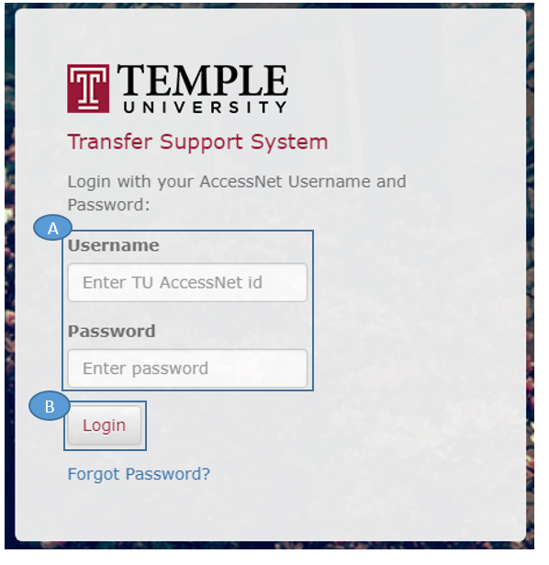

1. Fill out ***Username*** and ***Password*** fields with Temple AccessNet username and AccessNet password.
2. Click ***Log In***to be brought to the Advisor Dashboard.
   1. If you have forgotten your AcessNet password, the ***Forgot password?***link will redirect to accounts.temple.edu.

## 2.2 – ADVISOR Dashboard

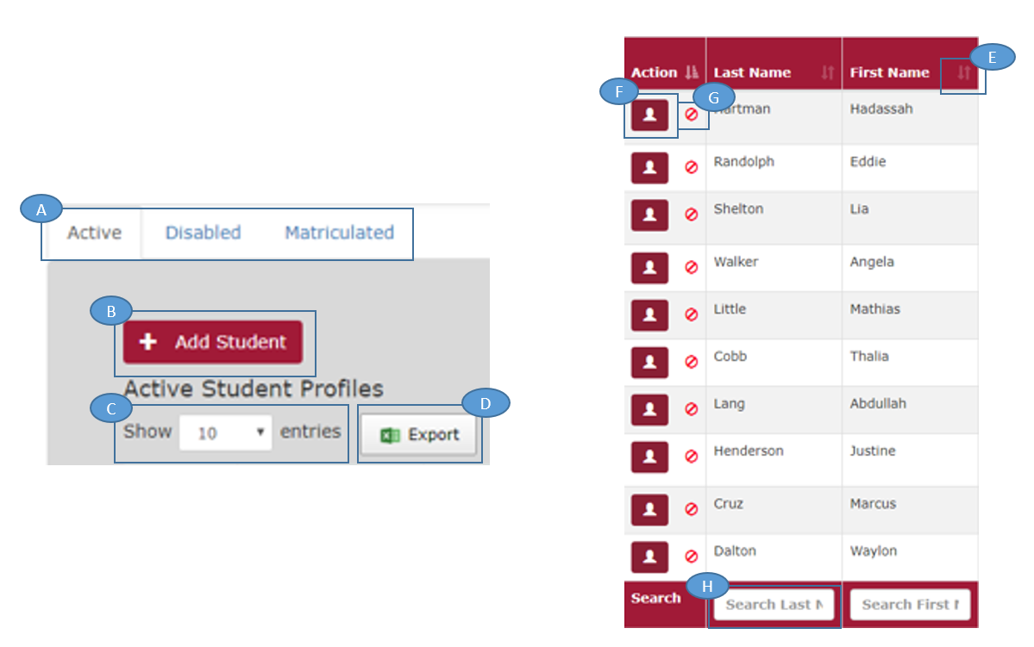

An Advisor will be able to use the Navigation bar located on top of the page to get back to the dashboard, access the manage pages, and logout.

1. Select Dashboard tab that displays all students who are either ***Active***, ***Disabled***, or ***Matriculated***.
2. Click ***Add Student*** to manually enter a student into the dashboard.
3. Click ***Show X entries*** to change the amount of profiles displayed per page.
4. Click ***Export*** to create an Excel sheet that displays all dashboard information.
5. Click the **Up and Down arrows** to switch between ascending and descending the profiles based on that field.
6. Click ***View*** to view the Student Profile.
7. Click ***Disable*** to inactivate a student profile and move it to the Disabled Tab.
   1. This feature is used in case of spam or duplicate entries.
8. Use the field based ***Search*** function to search for information only within a specific field.

## 2.3 – Add student profile

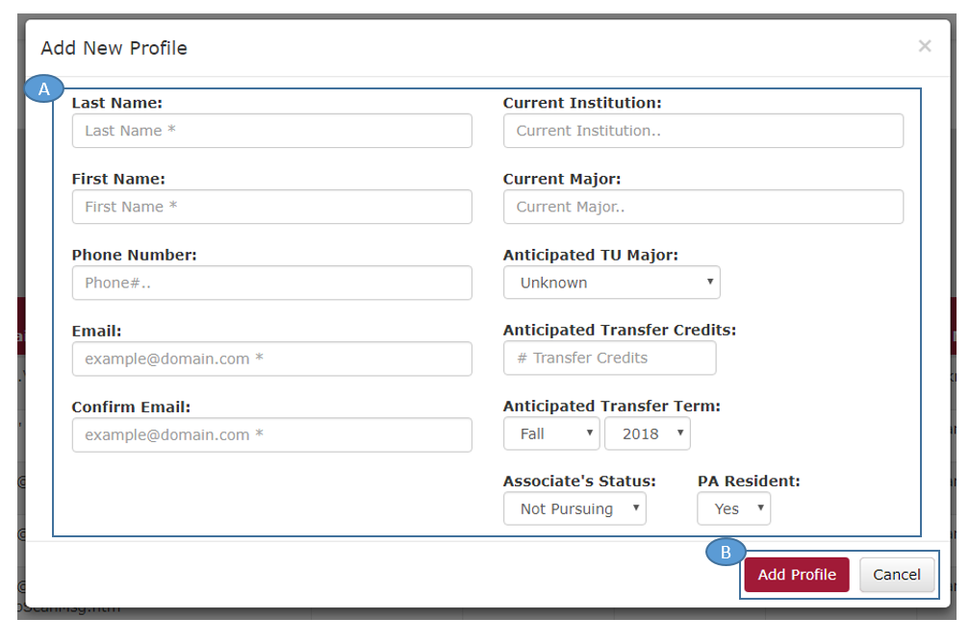

1. Fill out each field with information of a prospective transfer student. Fields with asterisks are required.
2. Click ***Add Profile*** to create a new student profile based on the information you have entered.
   1. This new profile will be placed in the ***Active*** tab on the dashboard.

## 2.4 – Student PROFILE

This is the student profile that will store information about each student. Conversation entries are manually entered following correspondence with a student.

1. Click ***Edit*** to unlock all of the student information in the profile. An administrator may now make changes to this information.
   1. Click ***Save*** to confirm the changes that were made.
2. Click the ***File Name*** to open an uploaded file.
3. Click the ***Delete*** symbol to delete an uploaded file.
4. Click ***Choose File*** to browse your PC for an academic file to upload.
5. ***Select the category*** that the type of file falls under.
6. Click ***Upload*** to save the document to the student profile.

## 2.4 – Student PROFILE

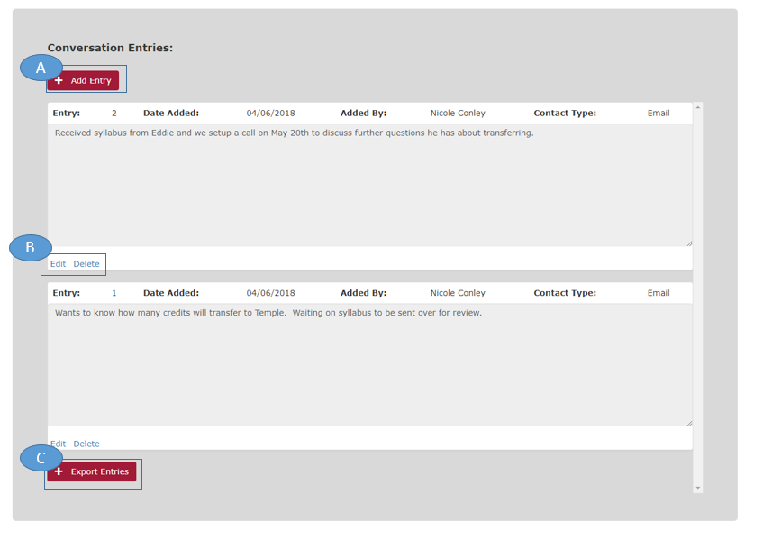

1. Click ***Add Entry*** to create a new conversation entry for the student.
2. Click ***Edit*** to make changes to that specific conversation entry.
   1. Click ***Delete*** to delete that specific conversation entry
3. Click ***Export Entries*** to move a matriculated students’ conversation entries to the ***TU Advising Database***.
   1. WARNING: This action is not reversible. If you decide to Export Entries, the student profile will be locked and moved to the Matriculated tab on the dashboard.

## 2.4 – Student PROFILE

1. ***Enter*** the conversation summary inside of the textbox.
2. ***Select the category*** of the conversation.
3. Click the ***Add Entry*** button to create a new conversation summary for the profile.

## 2.5 – eXPORT STUDENT

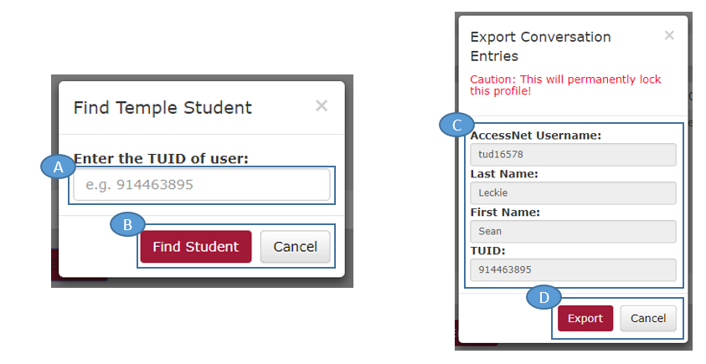

These are the popups that will appear after deciding to Export Entries on a Student Profile. If you complete these steps, you will no longer be able to make any changes to the student profile, and the conversation entries will be sent to the Official TU Advising Database.

1. ***Enter the TUID*** of the matriculated student.
   1. This information will need to be looked up separately.
2. Click ***Find Student*** to search for a student with that TUID.
3. ***Compare*** information with the TU Database to the one in the TSS Student Profile
4. If the information is a match, Click ***Export***.
   1. If the information does not match, Click ***Cancel***

## 2.6 – MANAGE MAJORS

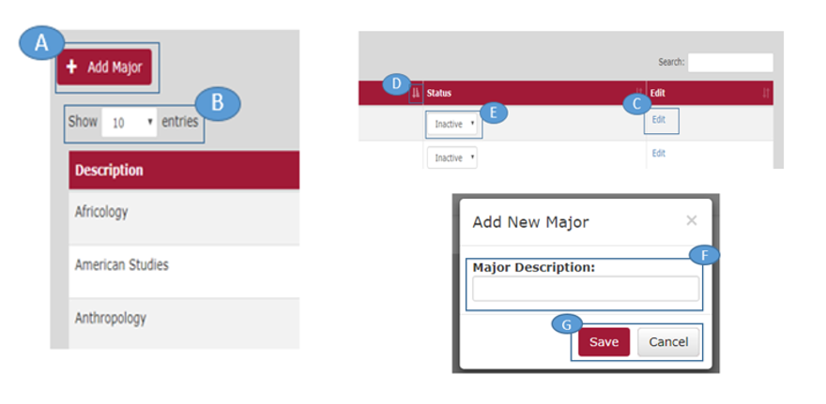

The Manage Majors page allows you to activate and deactivate the majors that will appear across the system based on what majors are offered from CLA

1. Click ***Add Major*** to add a new major to the major list
2. Click ***Show X entries*** to change the number of majors that are displayed per page.
3. Click ***Edit*** to change the name of the major.
4. Click the **Up and Down arrows** to switch between ascending and descending the profiles based on that field.
5. Click the ***Active/Inactive dropdown*** to activate or deactivate the major.
6. ***Enter*** the name of the major.
7. Click ***Save*** to add a major.

## 2.7 – MANAGE EMAIL

The Manage Email page allows you to edit the automated email that is sent to students after they have submitted a transfer question form.

1. ***Edit the Subject and Body*** of the automated email using the text editor tools.
2. Click ***Send Test Email*** to send one of the automated emails to the email address entered in the box.
   1. This is used to test the email and make sure the email appears how you expect it to.
3. Click ***Save*** to save the subject and body of the automated email.
4. Click the ***Disable Email*** checkbox to stop the automated email from sending to students.
   1. Note: The Send Test Email function will still work.

## 2.8 – MANAGE ADMINISTRATORS

The Manage Admin page allows an administrator to control who has access to the system.

1. Click ***Add Admin*** to add a new user to the system.
2. Click ***Show X entries*** to change the amount of users that are displayed per page.
3. Click the **Up and Down arrows** to switch between ascending and descending the users based on that field.
4. Use the ***Search*** function to display a specific Administrator.
5. Click the ***Access Level dropdown*** to change the user between Administrator and Reviewer.
   1. ***Administrators*** have full access to the system. ***Reviewers*** only have read access and cannot make edits or changes to the system.
6. Click the ***Active/Inactive dropdown*** to activate or inactive the user.
7. Click the ***Remove*** button to remove the user from the system entirely.

## 2.8 – MANAGE ADMINISTRATORS

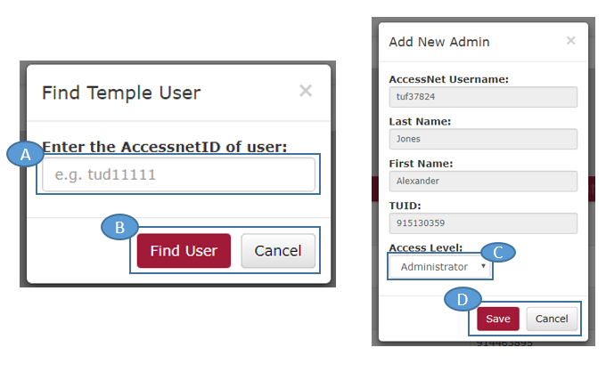The Manage Admin page allows an administrator to control who has access to the system.

1. ***Enter*** Temple AccessNet username of the desired administrator.
2. Click ***Find User*** to search for the person based off of the entered username.
3. Click the ***Access Level dropdown*** to change the user between Administrator and Reviewer.
   1. ***Administrators*** have full access to the system. ***Reviewers*** only have read access and cannot make edits or changes to the system.
4. Click ***Save*** to save the administrator to the system.

# 3 – sTUDENT

## 3.1 – sTUDENT TRANFSER FORM

The Student Transfer Form will be accessed by potential transfer students on the CLA website ad will be the start of a potential profile in the TSS.

1. Fill out each field with information about yourself. Fields with asterisks are required.
2. Ask any questions you may have about transferring to CLA at Temple.
   1. This question will show up as a ***Conversation Entry*** on the student profile.
3. Click on the ***reCAPTCHA*** to confirm you are human.
4. Click ***Complete*** to create a new profile in the TSS.
   1. A new profile with this students’ information will be added to the Active tab of the dashboard.
   2. An automated email is sent to the student confirming their form submission.